Unit11 How was your school trip?

Section B (2a-2c)

Reading 学案

—Guo Yan

**Learning goals:**

By the end of the class, we’ll be able to:

1. Grasp verbs and description words related to travel activities.

2. Can distinguish some positive words and negative words, and use them in the correct context.

3. Sort out the main content of the diary, and then retell the diary by reading the mind-map.

4. Understand that different people can feel differently about the same thing by reading the two diaries.

**While-reading**

Task: 1: Fast- reading.

1. Q1: What’s the type of the article? Q2: Which tense was used in it?

2. Play a game (Find out the verbs in the past tense as quickly as possible.)

3. Let Ss read Helen’s and Jim’s diary entries quickly, circle the description wordsand answer the questions.

Q1: When was the school trip?

Q2: Where did they go?

Q3: How did they go there?

Q4: How do they feel about the trip?

when

School trip

.

Jim

Helen

where

How

.

Task: 2: Careful- reading

1. Do Section B 2c. How do Helen and Jim describe these things?

|  |  |  |
| --- | --- | --- |
|  | Helen | Jim |
| the trip |  |  |
| the train |  |  |
| the museum |  |  |
| the gifts in the gift shop |  |  |

2. Read Helen’s diary again, and answer the questions.

1. What did Helen do in these places?

|  |  |
| --- | --- |
| On the train |  |
| At the museum |  |
| In the gift shop |  |

(2)What did the guide do at the museum?

3.Read Jim’s diary again. Why did Jim think the museum was boring? _____________________________________________________________________

**Post-reading**

Task: 1: Complete the mind map together, and then retell the diary.

Beginning

格式

Format）

Body

Ending

时态

Tense

Diary

When and where

Helen’s school trip

What

It was__________________

How

I visited _____on_________

(Jim’s school trip)

I think today’s school trip___________

Beginning

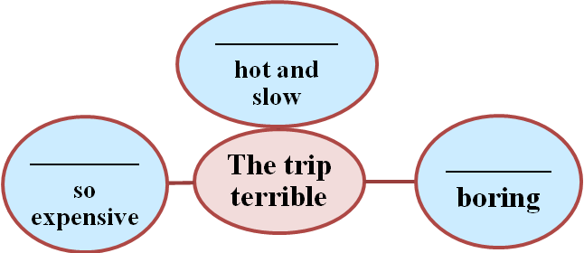

Body

Ending

I didn’t____________________.

Task2 Discussion

What can we learn from the diary entries?

(Different people have different feelings about the same thing; we should enjoy our life; be happy every day, etc.)

**Homework**

1. Retell the story after class.
2. Use the description words and verbs in the past tense to talk about your trip.